**Serverless Labs**

**1. Building a Serverless Web Application**

**Objective**: Create a serverless web application using AWS Lambda, API Gateway, S3, and DynamoDB.

**Approach**:

* **Set Up Backend**: Create Lambda functions to handle backend logic. These functions will interact with a DynamoDB table for data storage.
* **API Gateway**: Set up API Gateway to create RESTful endpoints that trigger the Lambda functions.
* **Frontend Hosting**: Host a static website on S3 that interacts with the backend via API Gateway.
* **Integration**: Ensure that the frontend can successfully send requests to the backend and display responses.

**Goal**: Understand the basics of building and connecting serverless backend services with a static frontend, enabling a fully serverless web application.

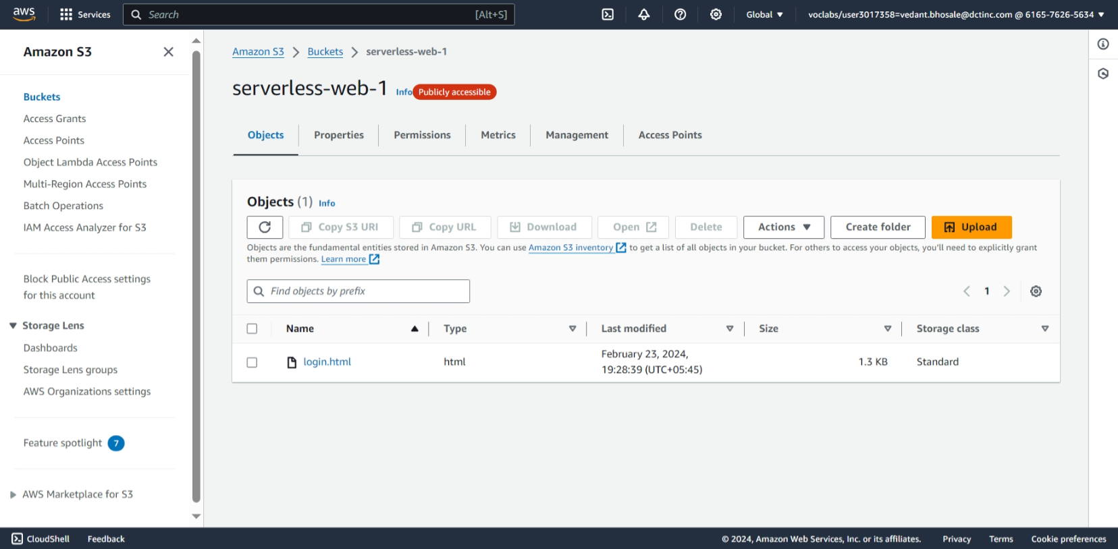

1. Create a s3 bucket and add a html file to host website
2. Enable static hosting and give bucket policy

{  
    "Version": "2012-10-17",  
    "Statement": [  
        {  
            "Sid": "AllowGetObject",  
            "Effect": "Allow",  
            "Principal": "*",  
            "Action": "s3:GetObject",  
            "Resource": "arn:aws:s3::: serverless-web-1 /*"  
        }  
    ]  
}

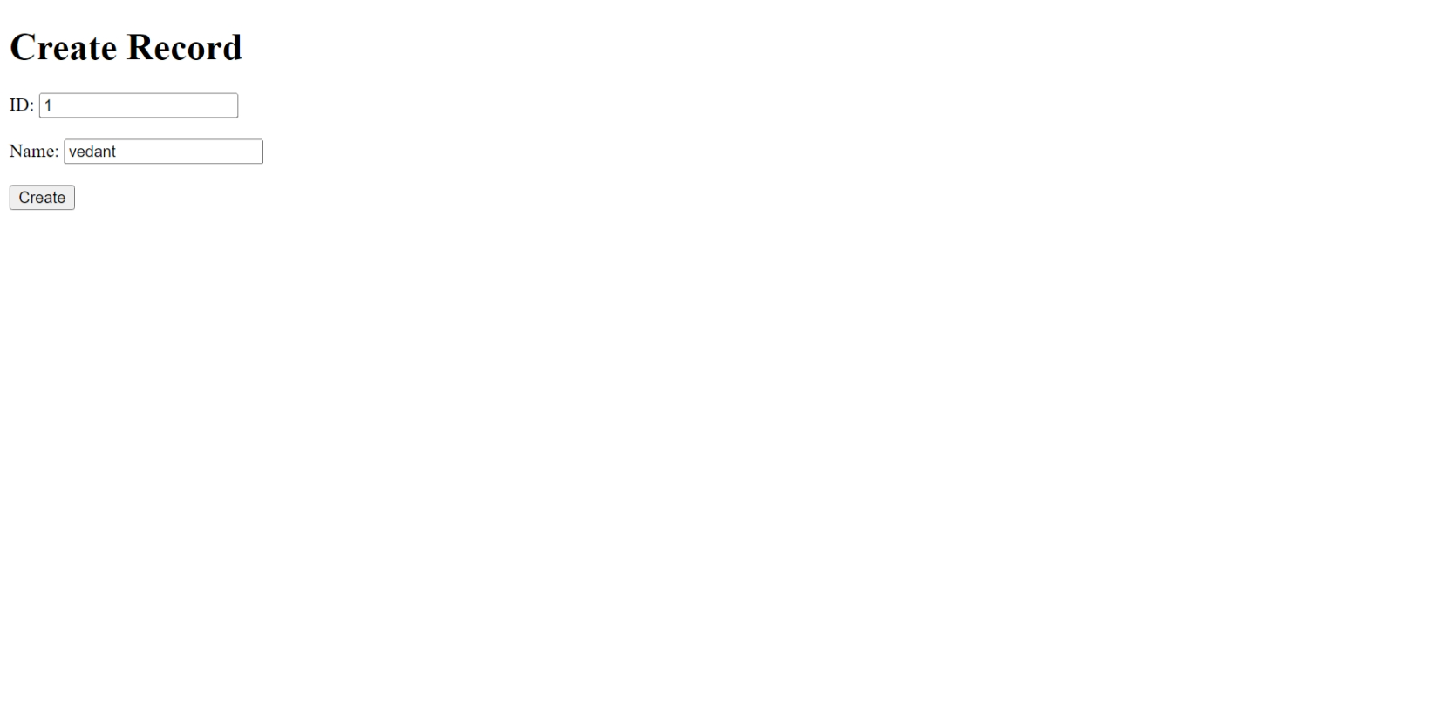

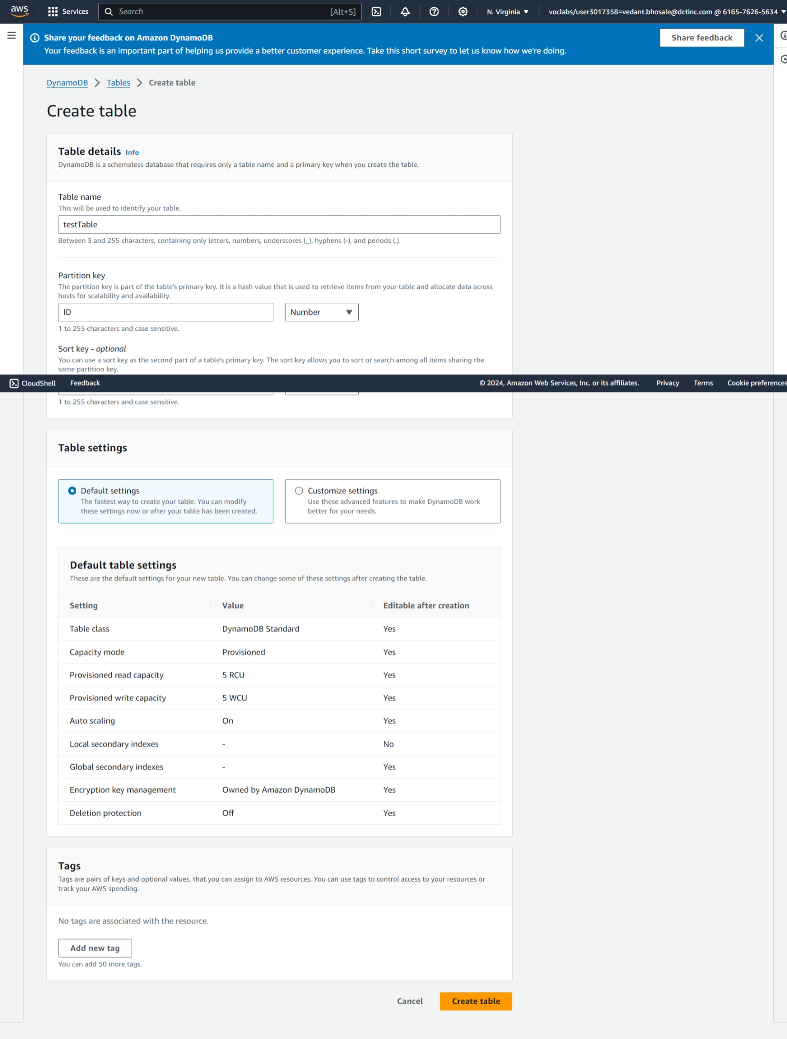

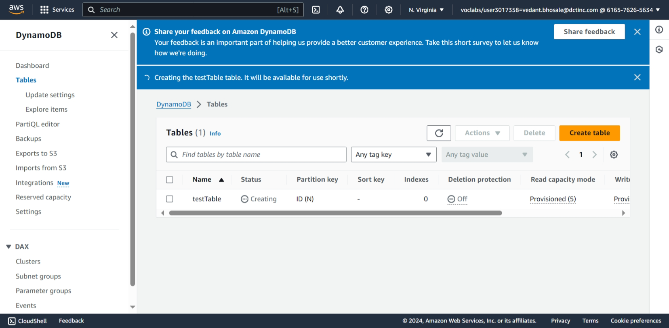

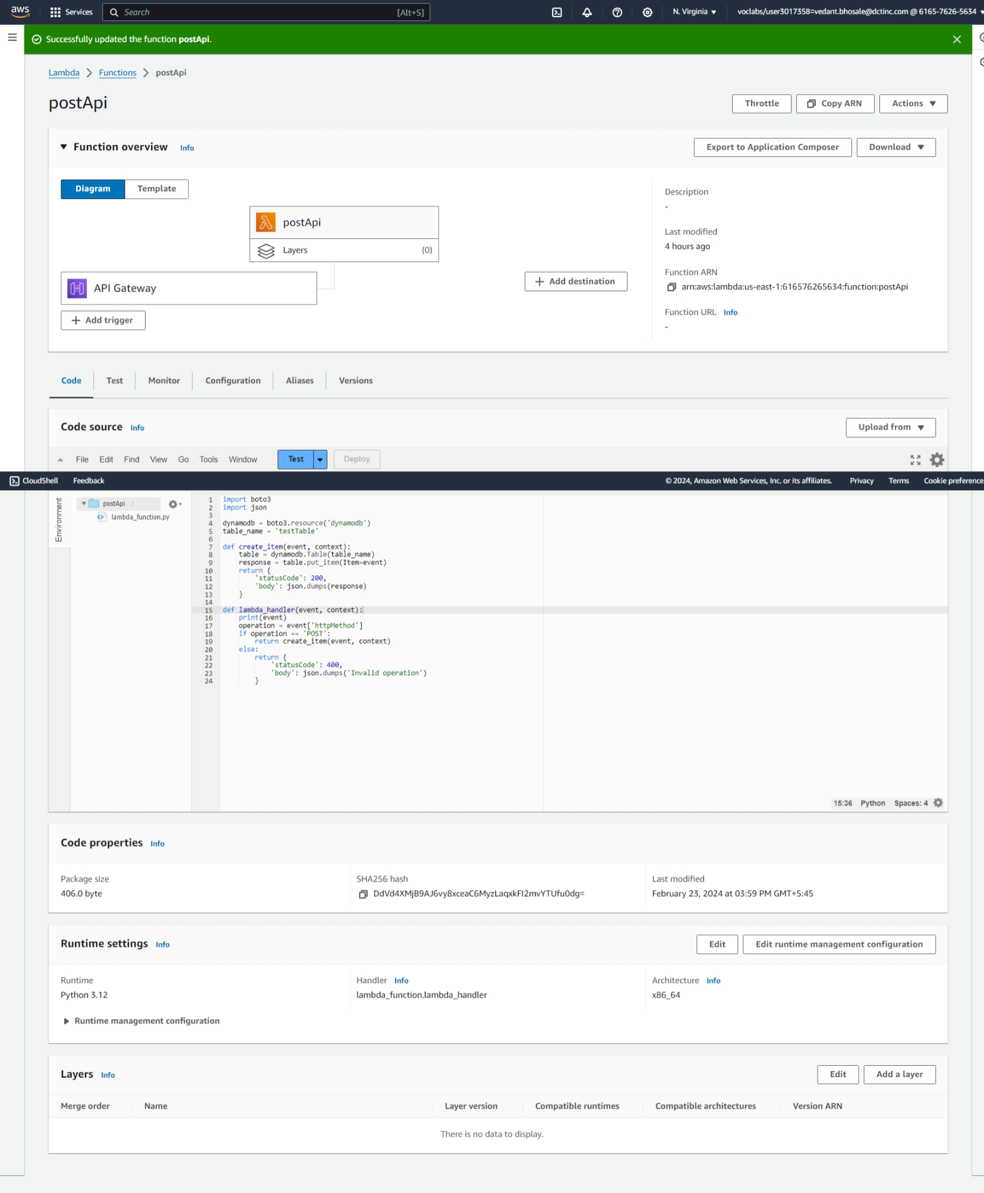

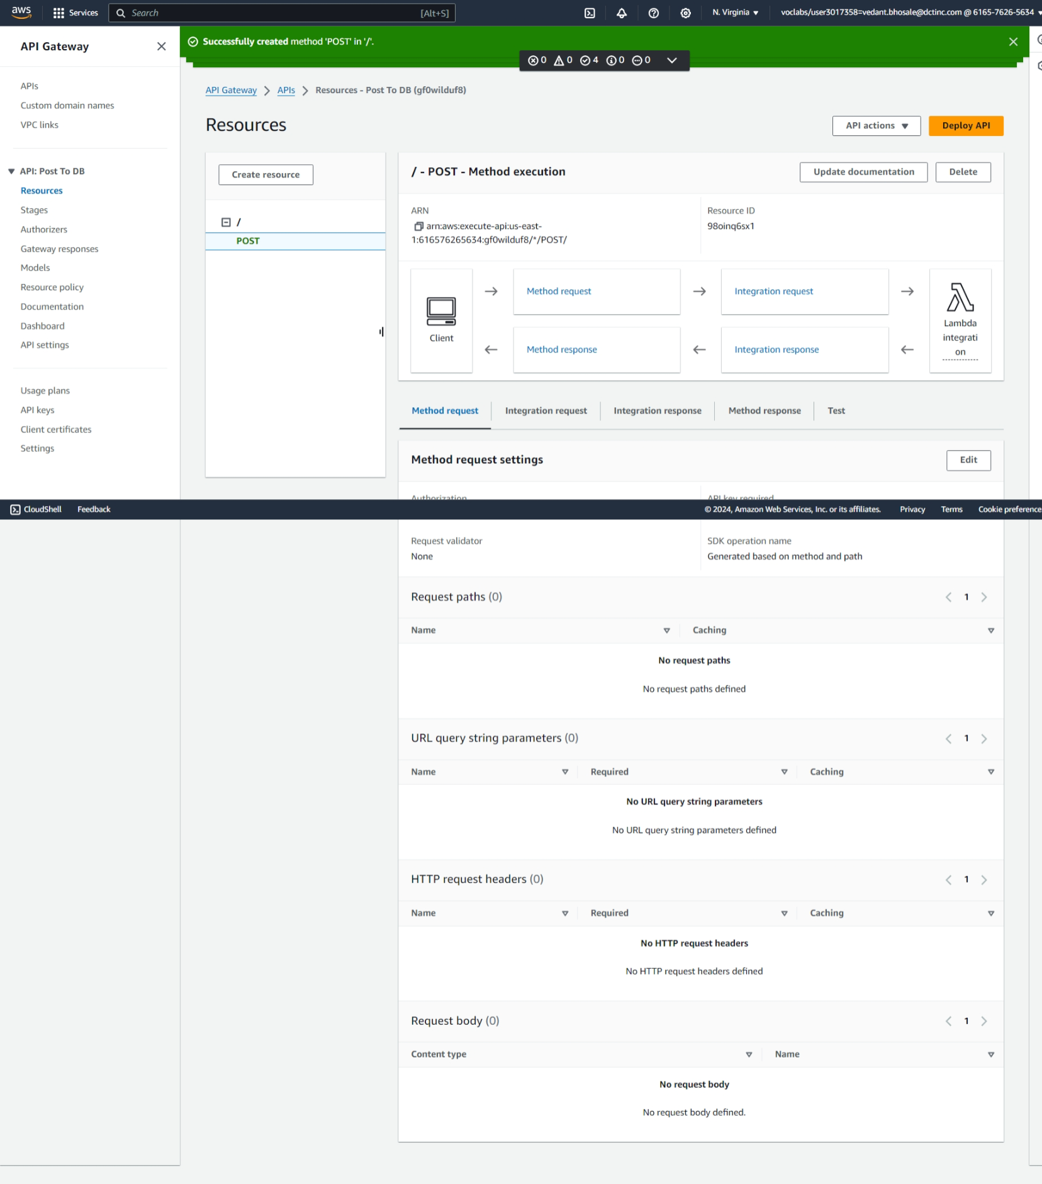



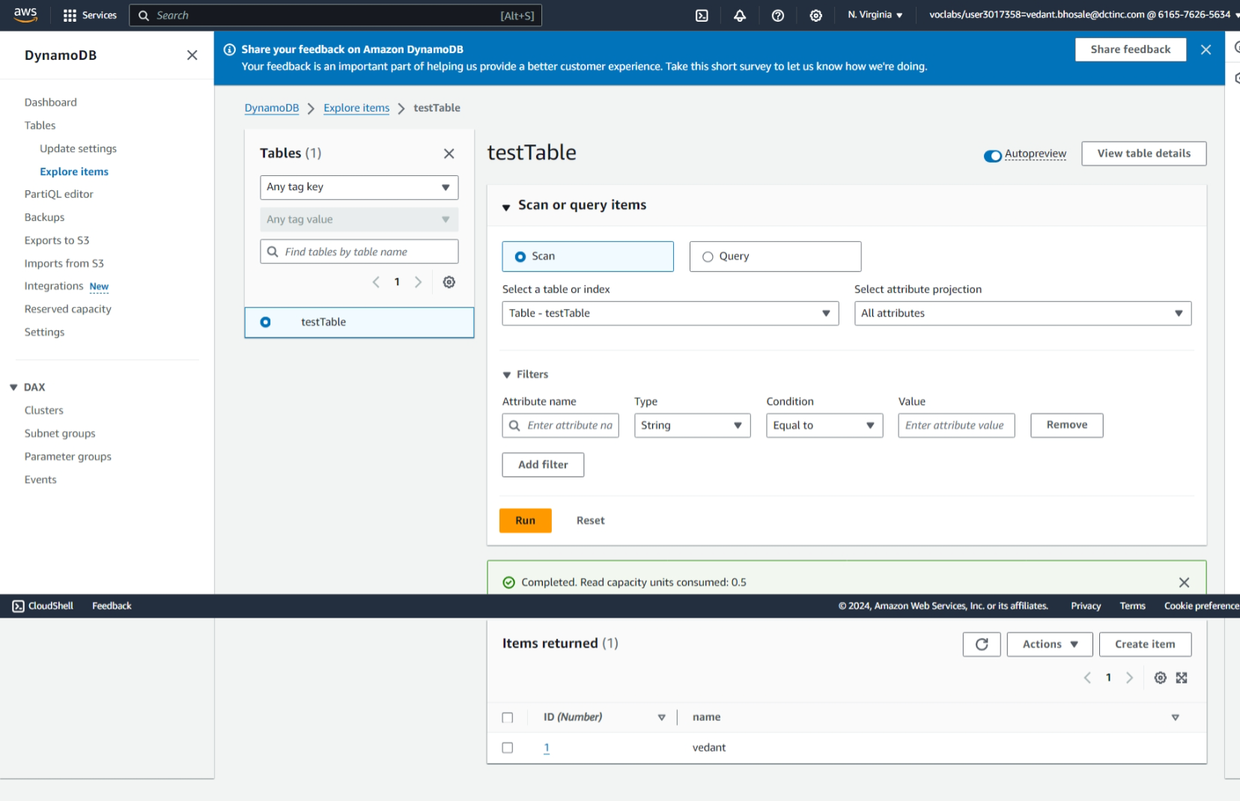

**2**. Creating a Serverless API\*\***

**Objective**: Develop a serverless API using AWS Lambda and API Gateway.

**Approach**:

* **Define API**: Design a simple RESTful API (e.g., for a todo list application).
* **Lambda Functions**: Create Lambda functions for each API method (GET, POST, PUT, DELETE).
* **API Gateway Setup**: Use API Gateway to set up the API endpoints, connecting each endpoint to the corresponding Lambda function.
* **Testing**: Test the API using tools like Postman or AWS API Gateway test functionality.

**Goal**: Gain hands-on experience in building and deploying a serverless API, understanding the integration between Lambda and API Gateway.

* 1. Creating lambda function for get api

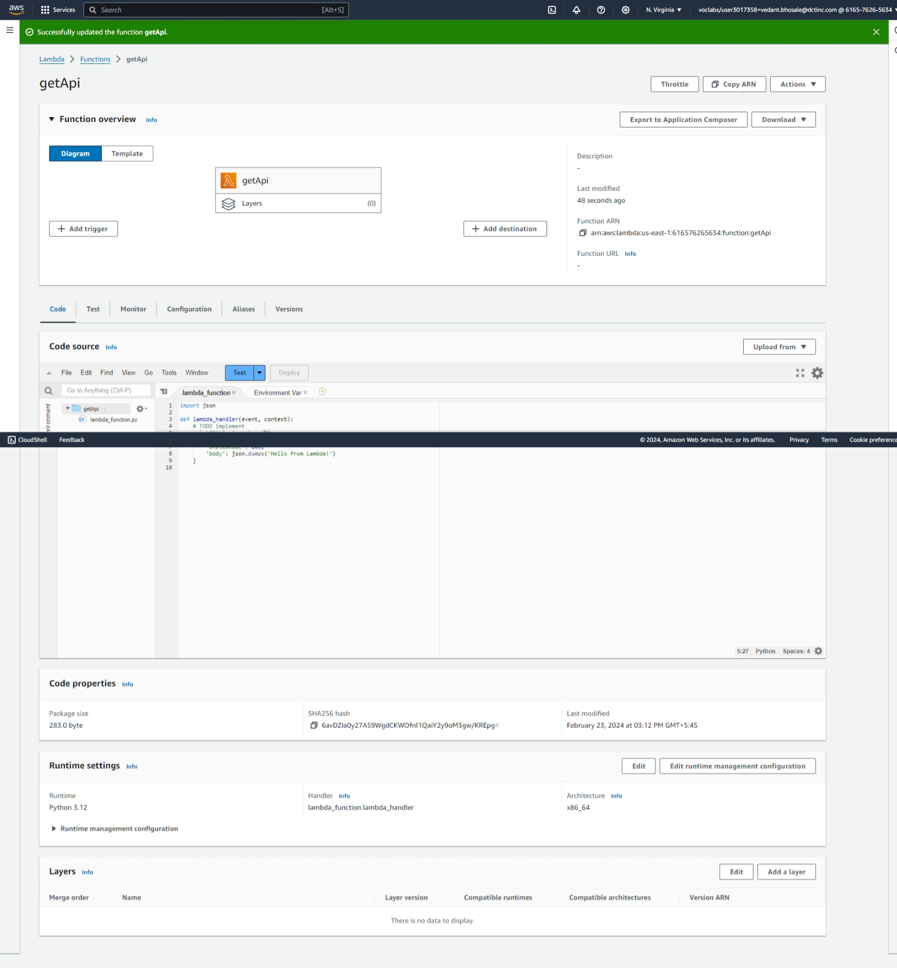

* 1. Repeat same step for post,put,delete
  2. In API getway create an api and create methods for get, put, post, delete

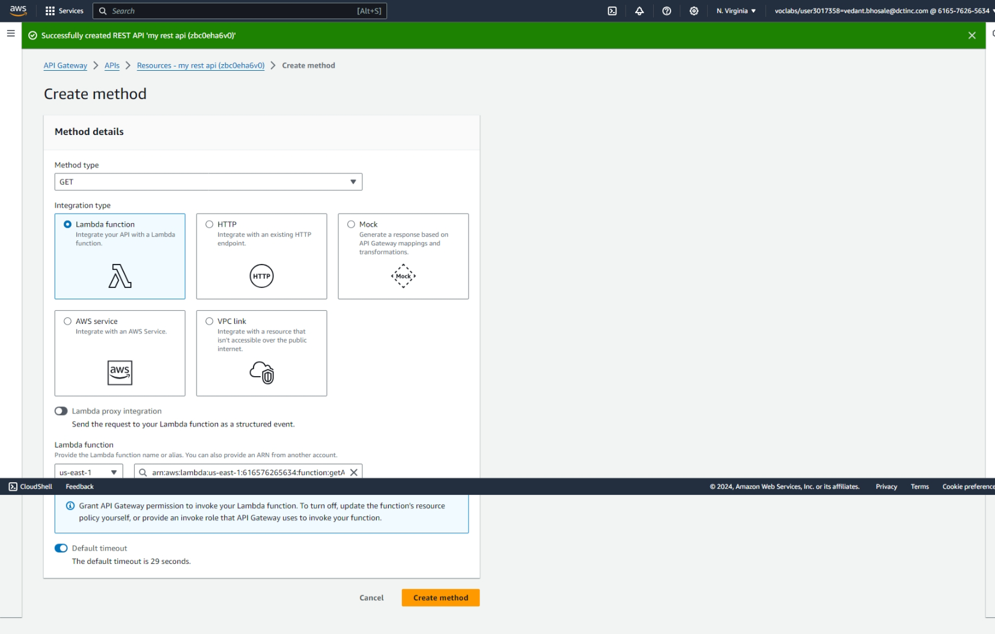

* 1. After creating methods deploy api

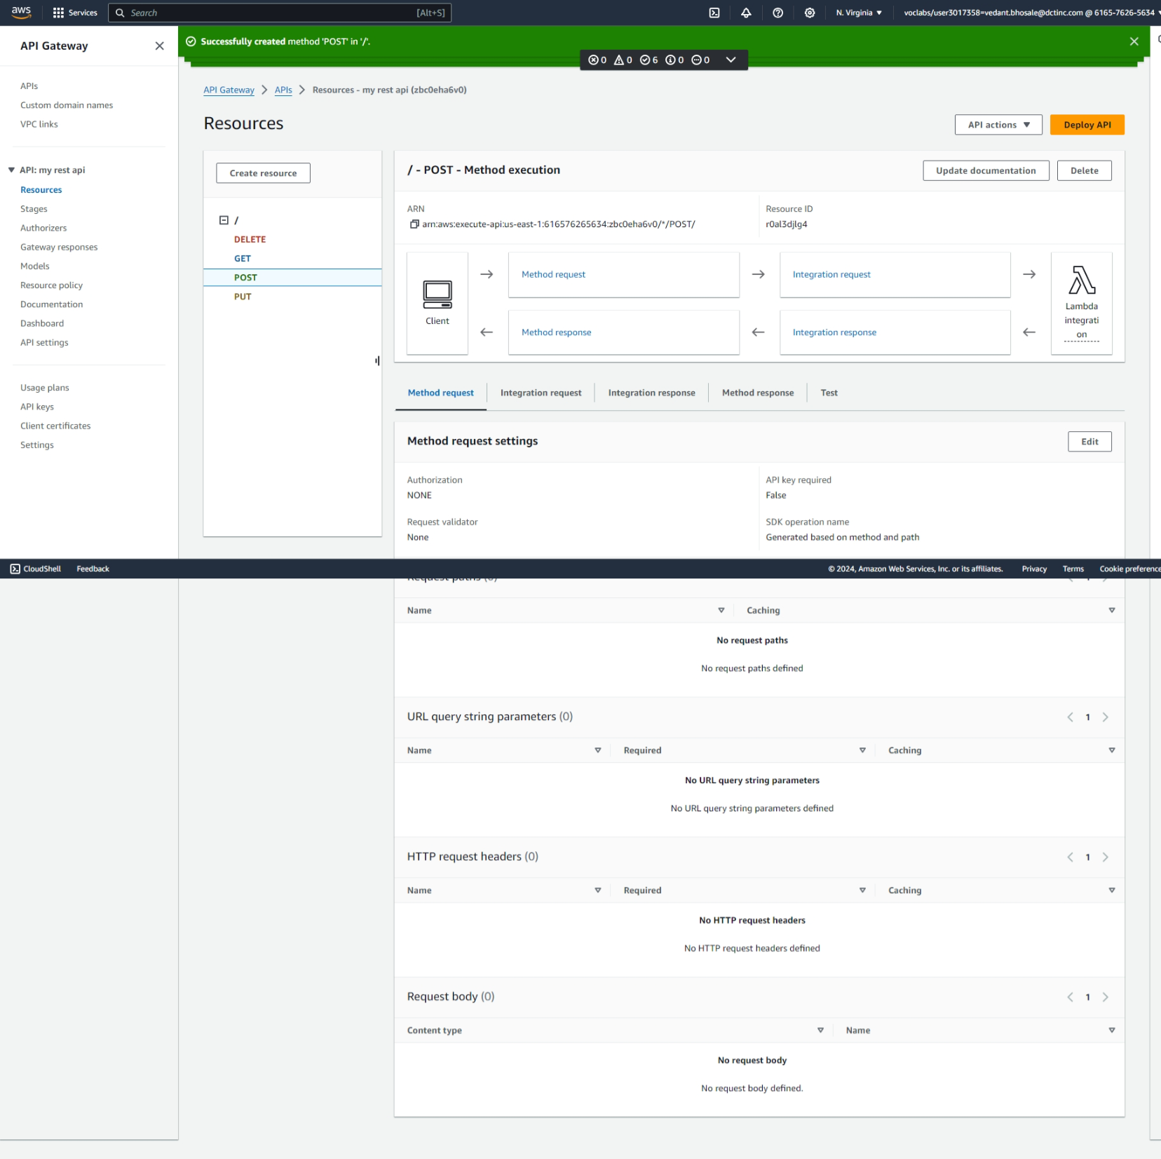

* 1. Create the stage

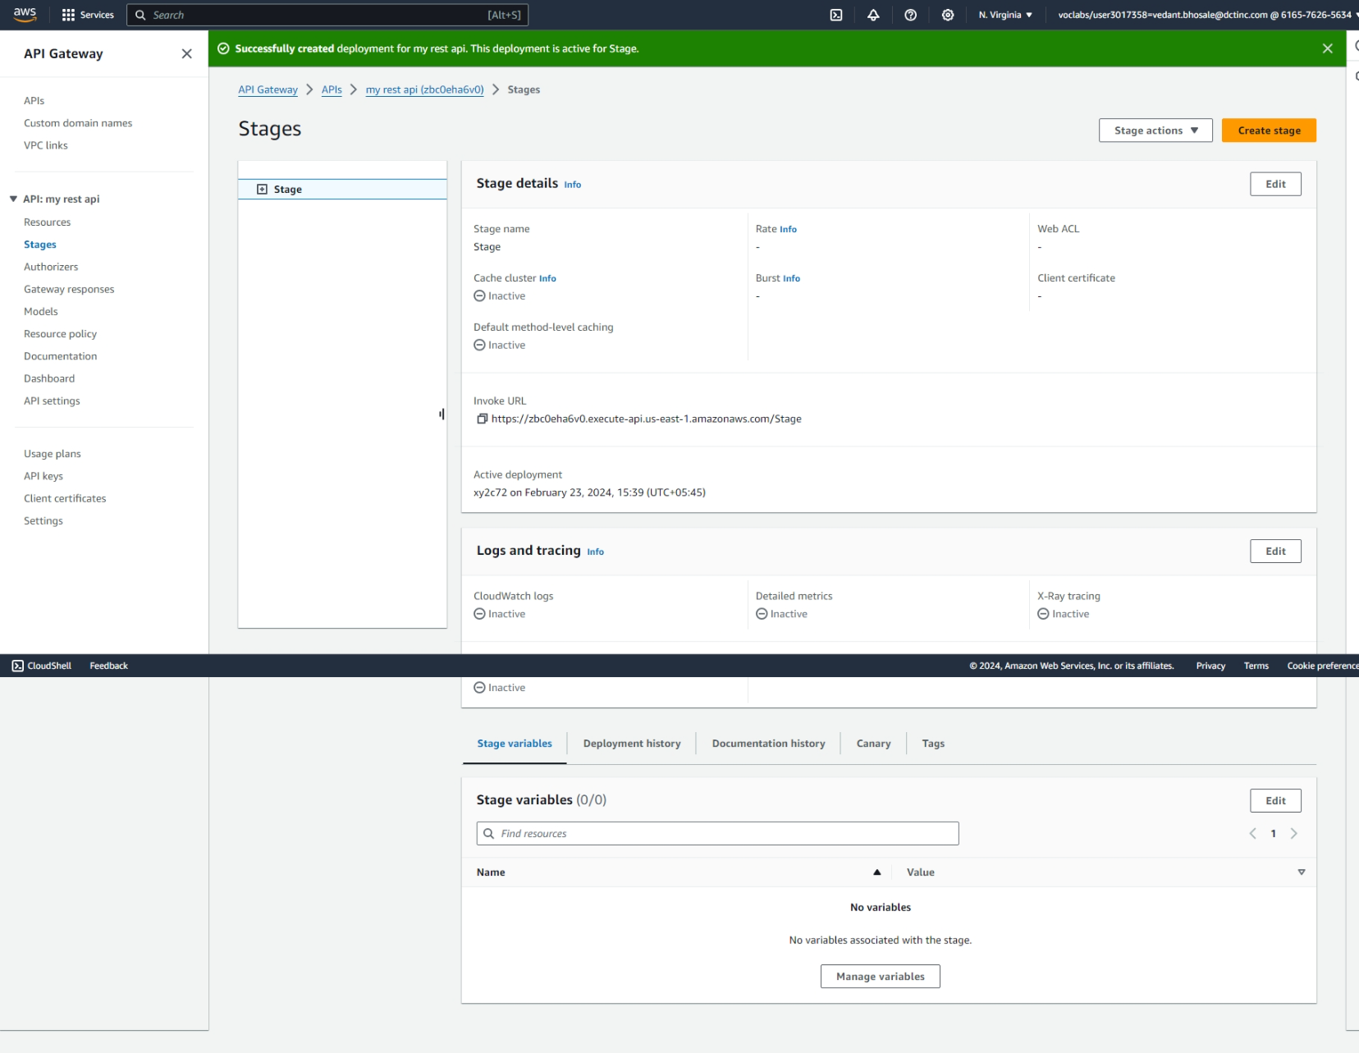

* 1. Testing each method using test

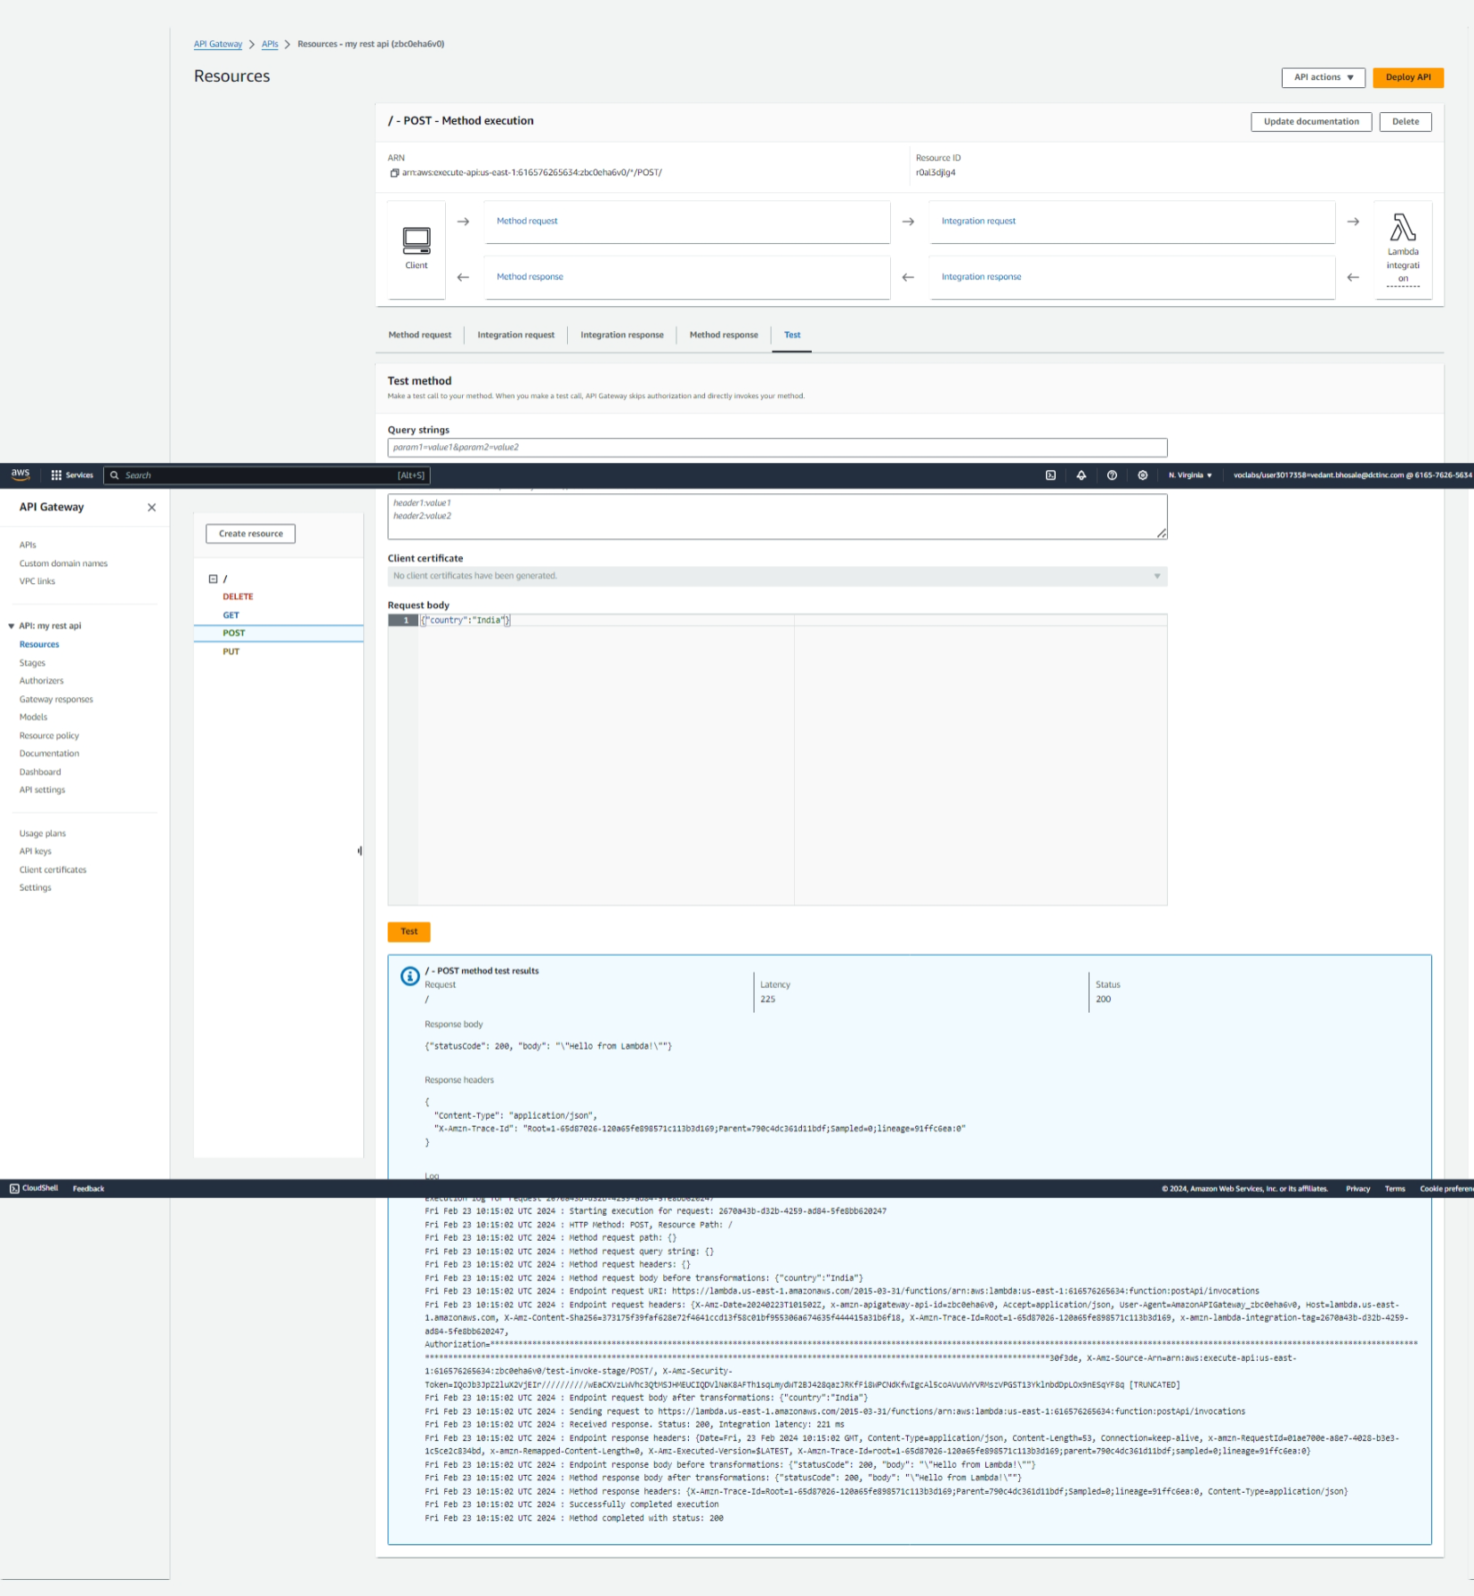

* 1. Here we can see the output generated in cloudwatch

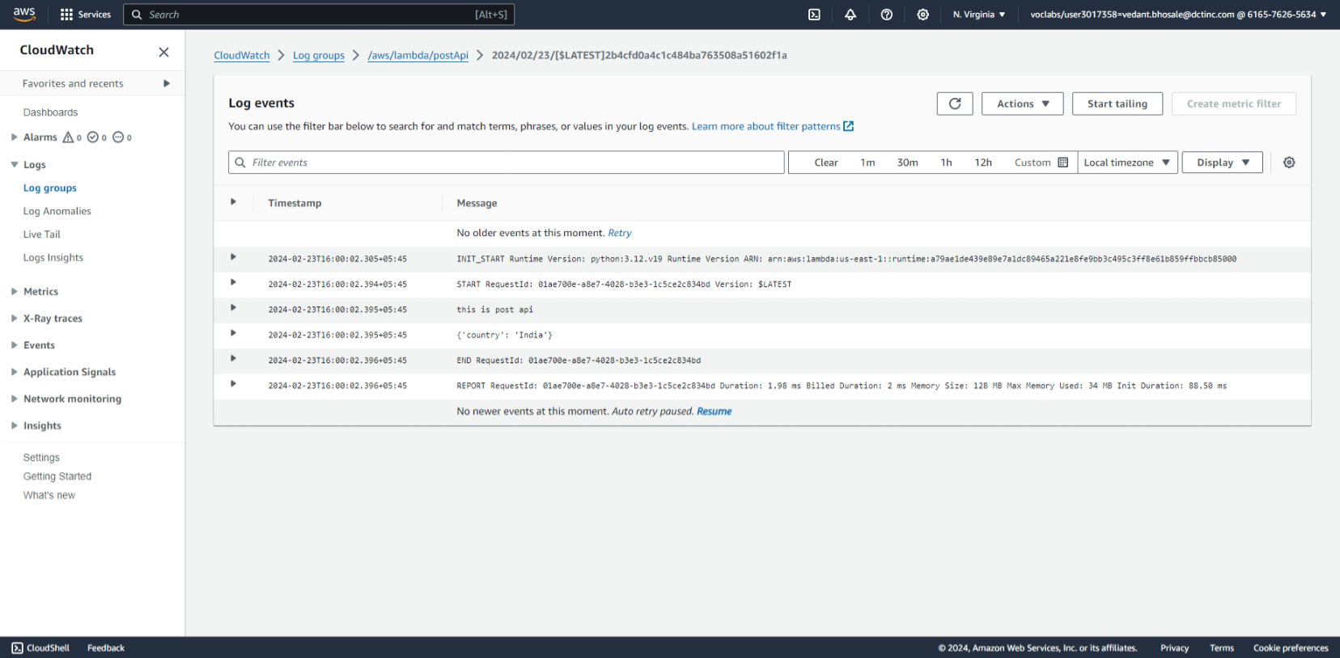

**3**. Serverless Data Processing Pipeline\*\***

**Objective**: Build a serverless pipeline for processing data (e.g., log processing or ETL jobs).

**Approach**:

* **Data Ingestion**: Use AWS services like S3 or Kinesis to ingest data.
* **Processing**: Create Lambda functions to process the ingested data.
* **Storage**: Store the processed data in an appropriate AWS service, like S3 or DynamoDB.
* **Monitoring**: Set up CloudWatch to monitor the pipeline's performance and to log any issues.

**Goal**: Learn to build a serverless data processing pipeline, understanding the flow of data through various AWS services.

